Gorgonea Quarta

It’s not necessary to use purely non-negative digits to compose numerals. Indeed, the denizens of the planet Gorgonea Quarta IV, perhaps due to the rather unusual configuration of their “hands” use a number system (the GQ system) in which there are three digits (called trits) ‘0’, ‘1’ and ‘-‘, having values 0, 1 and -1 respectively. In this number system, each position has a value 3 times that of the position to its right, Thus, the GQ numeral ‘10-‘ represents the decimal number 8 (since 8 = 1*9 + 0*3 +-1*1) and the GQ numeral ‘-1’ represents the decimal number –2 (since –2 = -1*3 + 1*1).

You have been given the incomplete static class GQ_Decimal_Converter. You need to implement two static methods.

The first method, toDecimal, takes a String representing a GQ number and returns an int, the decimal equivalent.

The second method, toGQ, takes an int representing the decimal value and returns a String representing the GQ equivalent.

Example
GQ_Decimal_Converter.toDecimal(“101”) returns 10
GQ_Decimal_Converter.toDecimal(“1-”) returns 2
GQ_Decimal_Converter.toDecimal(“-101”) returns -17
GQ_Decimal_Converter.toDecimal(“1---0”) returns 42
GQ_Decimal_Converter.toDecimal(“111-0-1”) returns 1024

And conversely
GQ_Decimal_Converter.toGQ(10) returns “101”
GQ_Decimal_Converter.toGQ(2) returns “1-”
GQ_Decimal_Converter.toGQ(-17) returns “-101”
GQ_Decimal_Converter.toGQ(42) returns “1---0”
GQ_Decimal_Converter.toGQ(1024) returns “111-0-1”

Notes on the problem from previous students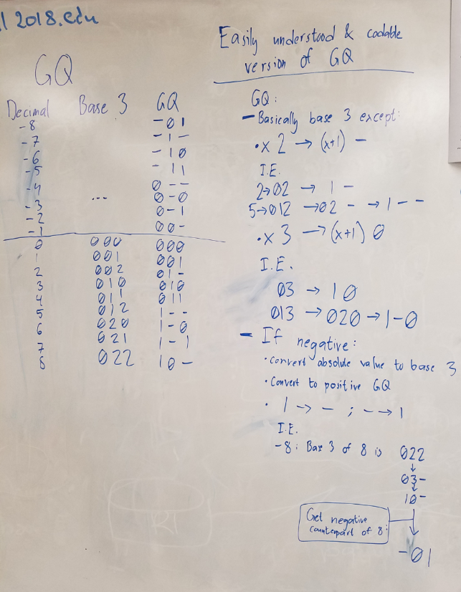

And Christos added the following comment – do NOT ask me to trasnslate!
